The Beginner’s Repertoire:
Proposing a Core Set of Instructional Practices for Teacher Preparation

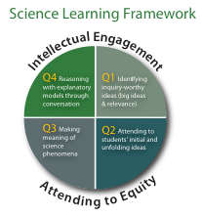

Mark Windschitl • Jessica Thompson • Melissa Braaten
University of Washington

DR K-12 Meeting, National Science Foundation, November 13th, 2009

Abstract
Recent calls for teacher education to become more grounded in practice (Grossman et al., 2009; Levine, 2006) prompt the questions: Which practice(s)? and perhaps more fundamentally, what counts as a practice worth learning for a beginning professional? Currently it is difficult to identify what gets taught during teacher preparation, we know only that it varies dramatically from one institution to the next, depending largely on the personal knowledge, experiences, and worldviews of individual instructors. In this report we argue the following:
1) Current preparation of educators, especially in the area of instructional methods, is under-informed by knowledge of how young people learn and uninformed by knowledge of how novice teachers learn to teach.
2) There are no commonly acknowledged sets of K-12 instructional practices in the various subject matters that the field of teacher preparation would consider “core” to the success of new educators.
3) If a defined set of subject-specific high-leverage practices could be articulated and taught in teacher preparation, the broader teacher education community could collectively refine these practices as well as tools and other resources that support their development in various classroom contexts.
4) Without an identifiable set of core practices to anchor instruction by both teacher educators and beginning teachers, improvement in instruction within and across institutions will continue to be isolated, individual, and haphazard.

Part of the solution is to bring current research to bear on the development of practices that all aspiring educators in the various subject matter areas can become proficient in—a recognizable beginner’s repertoire. This set of practices would be grounded in important learning goals for all K-12 students, the literature on how students learn, and emerging longitudinal research about how novices learn the craft of teaching.

This effort would be part of a larger agenda, that of developing a science of performance improvement (Bryk, 2009) for early career educators. By this we mean an evidence-informed system of learning opportunities, tools, and formative assessments tailored to the needs of teaching novices, that can support continuous movement towards effective and equitable classroom practice. From the standpoint of teacher education, the foundations for this endeavor would include defining a set of instructional practices that are fundamental to support student learning, and that can be taught, learned, and implemented by those entering the profession. The following story of our work with teachers over the past five years is focused on such practices in secondary science, but the lessons learned are easily translatable to other subject matter areas.

Informative Failures
At a conference we attended recently, a presenter was talking about new scholarships for promising teacher candidates. She spoke in glowing terms about the rigors of the preparation their awardees were about to undergo and mused publicly that “When we walk into their classrooms two years from now, I hope that we will be able to recognize that they have graduated from our program.” Members of our research group later discussed this hopeful prediction in the context of findings from a study we were conducting of new science teachers. These individuals had all completed the same preparation program but their eventual practice ranged from expert-like to unrecognizable in terms of what had been promoted in our university setting.

To illustrate, two of these novices had used the same curriculum to teach middle-schoolers about what causes the seasons. One of them used the teacher’s guide as a script, dutifully setting up labs in which the earth was represented by a styrofoam sphere on a stick and the sun was a flashlight. His students were directed to fill in an accompanying worksheet. When the class came to a close that day there was little discussion, only the ritual handing in of papers. In fifty minutes he felt he had “covered” the topic. Our second teaching novice, in contrast, began by breaking with the curriculum and asking students what they thought caused the seasons. Using students’ initial ideas she posed three possible explanations for why the earth was warmer in the summer and cooler in the winter. Over the course of a week, students were engaged in a variety of discussions and activities designed to gather evidence and counter-evidence for these explanatory models, in some cases proposing changes to the models themselves. Each day this teacher adapted instruction to shifts in students’ ideas, and in the process, engaged her students in reasoning like scientists about evidence and explanation.

Our research group struggled to understand how such a range of teaching approaches could emerge from one preparation program, and how preparation might be more uniformly effective.
We knew we had demonstrated “approaches” to instruction under the broad rubric of Model-Based Inquiry, and allowed our teacher education students to try these out under supportive conditions. However, we had not developed with our novices much in the way of specific practices that could be tied to student thinking, nor did we have the tools, resources, or shared language to help them recognize, plan for, carry out, and critique meaningful interactions with young learners.

But on a broader level, we were also asking: Why are there no signature pedagogies in science teaching that are recognizable across programs of preparation? Why is there no commonly acknowledged set of instructional practices that the field of science teacher preparation would consider core to the professional success of new educators?

These questions remain unanswered because the teacher education community has been unsuccessful, so far, at developing a science of performance improvement for early career educators. By this we mean an evidence-informed system of learning opportunities, tools, and formative assessments tailored to the needs of teaching novices, that can support continuous movement towards effective and equitable classroom practice. From the standpoint of teacher education, the foundations for this endeavor would include defining a set of instructional practices that are fundamental to support student learning, and that can be taught, learned, and implemented by those entering the profession. Those who teach teachers would need special forms of knowledge for such skilled practice and understand the special demands these types of instruction place upon beginners (Grossman & McDonald, 2008).

There are however no obvious agreements across teacher education programs about effective K-12 classroom practice in the various subject matters and virtually no discussion at all about effective practice in courses that prepare novices to design and carry out instruction. We know little, for example, about preparation that occurs in methods classes (Clift & Brady, 2005). We have no clear picture of how they portray effective practice, nor of the pre-teaching experiences these courses provide (Grossman et al., 2009). In a study of curriculum in teacher education programs, Levine (2006) found that eclecticism was the rule at both the program level and in methods courses where classroom strategies were the focus. It seems the only consistency across programs is that most teacher preparation remains largely teacher-centered, focusing principally on instructional procedures and management strategies (Adams & Krockover, 1997; Freese, 2006) and less in terms of student thinking and learning.

Contributing to this lack of principled consistency across preparation programs is the underdeveloped knowledge base for teaching which precludes, among other things, a shared language of the core classroom practices and theory of how novices learn to design and enact effective instruction (Heibert, Gallimore, & Stigler, 2002).¹ There are few systems in place for documenting and sharing knowledge across programs that educate teachers (Morris & Hiebert, 2009). As a consequence, there exists no shared professional curriculum to prepare teachers. Opportunities for teacher candidates to learn about classroom practice are constrained by the past experiences, skills, and personal theories of their instructors and cooperating teachers whose courses are often designed without the benefit of evidence-based understanding of what novices should learn or how they learn (Ball, Sleep, Boerst, & Bass, 2009). The result is a nationwide collection of programs that have few mechanisms for systematically contributing to the improvement of teacher preparation.

Given the lack of focus and consistency within and across preparation programs, we join with other science and mathematics education researchers in proposing a radical re-thinking of how novices can begin to learn the craft—through the development of a set of specified high-leverage instructional practices for use in K-12 classrooms that can be taught to and implemented by beginning secondary educators (see also Franke & Chan, 2007). This set of practices would be grounded in important science learning goals for K-12 students, in the literature of how students learn, and in emerging longitudinal research about how novices learn the craft of teaching (Nolen, Ward, Horn, Childers, Campbell, & Mahna, in press; Thompson, Windschitl, & Braaten, 2009). We further propose that these be taught and assessed in some consistent way across all early learning-to-teach contexts as novices move from university coursework, to student teaching, and into their first years of professional work.

Our vision is that high-leverage practices (HLPs) make up the core repertoire of ambitious teaching. Ambitious teaching deliberately aims to get students of all racial, ethnic, class, and gender categories to understand science ideas, participate in the discourses of the discipline, and solve authentic problems (Lampert & Graziani, 2009; Newmann & Associates, 1996; Windschitl, Thompson, & Braaten, 2009). This kind of pedagogy is both adaptive to students’ needs and thinking, and maintains high standards of achievement for all learners. Teachers who can adjust both content and methods to what they observe in student performance are more likely to enable all kinds of learners to succeed at high-quality work (Fennema, Franke, Carpenter, & Carey, 1993; Hill, Rowan, & Ball, 2005; Lee, 2007; Rosebery, Warren, & Conant, 1992; Smith, Lee, & Newmann, 2001; Warren & Rosebery, 1996).

In this report, we describe the development and testing of four high-leverage practices for secondary science teachers. This story is possible because of the generosity of twelve teaching novices, whose thinking and practices were carefully chronicled for more than three years. Their struggles and successes in taking up ambitious practice informed not only our designs for a “beginner’s repertoire,” but also a system of tools and socio-professional routines that could support such teaching over time. Thus, we also introduce initial accounts of a second cohort of science teachers, who are now trying out these tools and routines. In the process they are helping us re-define what is possible for early career teachers and for teacher education.

What Are High-leverage Practices?
Defining Criteria
The idea of HLPs has been developed within the mathematics education community and in particular by Franke and Chan (2007) and Ball and colleagues (2009), whom we paraphrase here. Broadly speaking, high-leverage practices are those most likely to stimulate significant advancements in student thinking when executed with proficiency. For example, one of the HLPs that we discuss later is eliciting students’ ideas in order to adapt further instruction. This is a discourse strategy that helps teachers build upon the ideas that students bring to the classroom. Focusing on such practices equips the beginning teacher with skills that are unlikely to be learned through personal experience. The following criteria for HLPs are based on the nature of teaching itself and on the exigencies of the teacher preparation context (from Ball et al. 2009, p. 460).

Criteria for HLPs based on examinations of the work of teaching:
• Helps to improve the learning and achievement of all students
• Supports student work that is central to the discipline of the subject matter
• Are used frequently when teaching
• Applies to different approaches in teaching the subject matter and to different topics in the subject matter

Criteria for HLPs necessitated by teacher preparation contexts:
• Are conceptually accessible to learners of teaching
• Can be articulated and taught
• Are able to be practiced by beginners in their university and field-based settings
• Can be revisited in increasingly sophisticated and integrated acts of teaching

To these lists we add three important criteria:
• First, HLPs should be few in number to reflect priorities of equitable and effective teaching, and to allow significant time for novices to develop beginning instantiations of each of these practices.
• Second, each HLP should play a recognizable role in a larger, coherent system of instruction which supports student learning goals. A single HLP, while accomplishing important aims, cannot by itself address the broader agenda of ambitious pedagogy.
• Third, HLPs should have features that readily allow novices to learn from their own teaching. An example here would be instructional routines that make students’ thinking visible and that create a record of students’ developing ideas and language across units of instruction in forms that allow teachers to reconcile these changes with instructional decisions they made along the way.

Up to this point, we have talked about teaching generically, yet it is not difficult to see that the deliberations about what constitutes a productive set of HLPs will take into account specific features of the subject matter disciplines. In the following section, we discuss contemporary developments in science education research that informed our choices about selecting HLPs.

Using Literature in the Subject Matter Area to Inform HLPs
Messages about effective instruction in K-12 science classrooms have been consistent across all recent reform documents (summarized in National Research Council, 1996; National Research Council, 2005; National Research Council, 2007). But messages about what we want students to understand and be able to do provide only suggestions as to what teachers should be able to do, and tell us nothing about the skills and understanding required to foster that kind of teacher learning. For example, Science Teaching Standard B in Inquiry and The National Science Education Standards (National Research Council, 2000, P. 22) states that “Teachers guide and facilitate learning. In doing this teachers orchestrate discourse among students about science ideas.” After reading this standard, teachers and teacher educators may well ask, “What does this discourse sound like?” “Who is saying what to whom, and why?” This document also offers an “instructional models” summary and vignettes of master teachers, but even these do not clearly describe what teachers should be able to do in support of learning. The ends are clear but the means to achieving those ends remain underspecified.

Similarly, the recent consensus publication Taking Science To School (NRC, 2007) points out elements of classroom activity that have been shown to support student learning goals. But again, the purpose of this document was not to serve as a reference for guiding teacher preparation by articulating the details of practice or the underlying understandings and skills necessary to support these types of instruction. Nonetheless, this volume has done an exemplary job of summarizing the proficiencies for students² and, we believe, for teachers who are responsible for guiding young science learners. Students and teachers should be able to:
• understand, use, and interpret scientific explanations of the natural world,
• generate and evaluate scientific evidence and explanations,
• understand the nature and development of scientific knowledge, and
• participate productively in scientific practices and discourse (p. 334).

We used this document, along with other authoritative publications in science education and our own collective classroom experience to outline a set of possible HLPs. However we felt we were still missing a key piece of the puzzle—a credible developmental model for how beginning teachers learn to take up, filter out, or re-invent ambitious pedagogy as they move through early learning-to-teach contexts.

Tracking the Teaching of Novice Educators
In our own teacher education program we were responsible for the methods course, which featured our version of ambitious teaching. This kind of teaching included experiences with eliciting K-12 students’ prior knowledge, conducting model-based inquiry experiences for learners, and helping learners develop explanations for scientific phenomena (this was prior to our development of HLPs). From extensive observations of former graduates of our program, we knew that no beginning teacher unproblematically emulates practices from their pre-service program when they move into their own classrooms, but we wanted to understand how and why certain practices were appropriated in this transition. To accomplish this, we followed a group of teacher candidates through their pre-service program into secondary classrooms as they began student teaching, into their first year of teaching, and for several into their second year. Not surprisingly we found great variation in how they translated what they had learned in teacher preparation into their own classrooms. Some exhibited expert-like practice in their first year, while others languished in traditional forms of teaching that bore little resemblance to what they had been exploring in their preparation program. But what eventually informed the design of the HLPs were four challenges they all faced—each involving how to make scientific ideas accessible to students (see Thompson, Windschitl, & Braaten 2009).

The first of these four challenges was that many of our beginners could not identify big ideas to teach. By “big ideas” we mean substantive relationships between concepts in the form of scientific models that help learners understand, explain, and predict a variety of important phenomena in the natural world. Such ideas were rarely stated as such in their curriculum. Indeed many curriculum units or textbook chapters were not based in important science ideas at all. Our participants however felt obligated to take mundane topics (e.g. “glaciers”, “sound”, “solutions”) at face value and not seek deeper or more comprehensive scientific ideas that could help students make sense of the many activities prescribed in the support materials. In 73 classroom observations we found only 27 instances in which these beginners made adaptations to the central topics of the curriculum, and only 8 instances in which they transformed the topic into a big idea. Most participants conformed to what their colleagues in the school were teaching, or merely altered minor lesson details.

Some participants were able to reconstitute their curriculum around big ideas. For example, during student teaching one novice was given a unit entitled “Batteries and Bulbs.” Even though this individual was a promising educator, he believed that it was his duty to teach the mechanics of batteries and bulbs and for his students to complete exercises in making different kinds of circuits as well as comprehend the rules that governed them. Only after teaching for several days did he realize that the underlying big idea was the transformation of energy. At that point his instructional goals shifted, and his teaching was re-focused away from an emphasis on the material make-up of equipment and rote recall of rules to having students develop and test models of energy transformations within electrical systems. When documenting participants’ attempts at different forms of ambitious teaching in their own classrooms, we found that identifying a big idea was a critical pre-condition to trying out sophisticated forms of instruction. There were, in fact, no instances in which a participant took up a curriculum topic without modification and then attempted any form of ambitious teaching.

The difficulty our first cohort of participants experienced in identifying big ideas to teach can be partially explained by the literature. Beginning science teachers’ content knowledge is often superficial (Anderson, Sheldon, & Dubay, 1990; Duschl, 1983; Gallagher, 1991; Pomeroy, 1993; Sanders, 1993; Westbrook & Marek, 1992) and poorly integrated (Gess-Newsome & Lederman, 1993). Both the superficiality and fragmentation likely contributes to the tendency for novice educators to accept topics listed in curricula at face value and teach them uncritically as important science ideas (see Davis, Petish, & Smithey, 2008).

The second challenge for beginning teachers was organizing productive discourse in the classroom. They often knew how to get student conversations started (with a puzzling question or demonstration) but would report to us that they “didn’t know where they were headed” in the ensuing discussion. This struggle appeared across all forms of classroom discourse. They essentially had no guiding framework for engaging students in talk that was equitable in terms of participation, and productive in terms of developing science questions or ideas.

The third challenge for participants was translating the vision of Model-based Inquiry, which had been heavily promoted in the methods class, into a coherent framework for student investigation and explanation. Although we had provided opportunities for participants to engage in this type of inquiry themselves as learners during the methods class and had supported them in designing lessons around this investigative paradigm, many of them retained only a gestalt vision of this form of inquiry, a vision that was easily over-written by the vagaries of “The Scientific Method” found in most curricula. When falling back on the Scientific Method, some of our teachers tended to focus their students exclusively on procedure and experimental design at the expense of the intellectual work involved in developing evidence to support scientific explanations.

Finally, as we followed our participants into their first year of teaching we realized how long it takes for new teachers to become modestly proficient in just one valued form of practice. During the entire first year of induction we engaged participants in the collaborative examination of their own pupils’ written work—this around constructing evidence-based explanations. Even with the duration of this support and the regular provision of feedback, some participants could not, after a year, put their students in situations where they were using evidence to support causal explanations of natural phenomena.

Each of these four challenges compelled us to think about the teacher preparation experience, the treatment of science as subject matter, the influences of school context, and how each participant’s vision of good teaching influenced the trajectory of beginning practice. These concerns catalyzed our reconceptualization of the methods course through a focus on high leverage practices. Equally important to us was considering how this set of practices could be fostered and across the full continuum of learning-to-teach contexts—the kinds of settings that are notorious for “washing out” the effects of teacher preparation (Zeichner & Tabachnick, 1981).

Constructing High Leverage Practices
We identified four practices that fit the criteria described earlier for HLPs. By “teacher practice” we mean a purposeful, regularly occurring set of decisions and actions that take into account subject matter, students, and classroom context, and that have learning as the ostensible goal. We purposely limited the number of HLPs, given that each of them would require the use of specially developed tools, multiple opportunities for rehearsal and feedback in different contexts, and participants’ reflection on performances of that practice. It is important to distinguish our version of HLPs from others described in the literature, particularly in mathematics. Ours are not tied to particular topics or skills, rather, they are planning or enactment practices that aim to engage learners in forms of discourse that lead to and embody learning. These are “meso-level” practices, meaning a set of instructional moves in which various micro-level practices (such as offering targeted feedback to students, asking a student to explain her thinking, or presenting key parts of a scientific model to students) are strategically combined to allow students to participate in valued learning activities. Importantly, each of the practices was designed to play a role within a broader, coherent approach to ambitious teaching. This system we referred to as the Science Learning Framework (SLF—Figure 1).
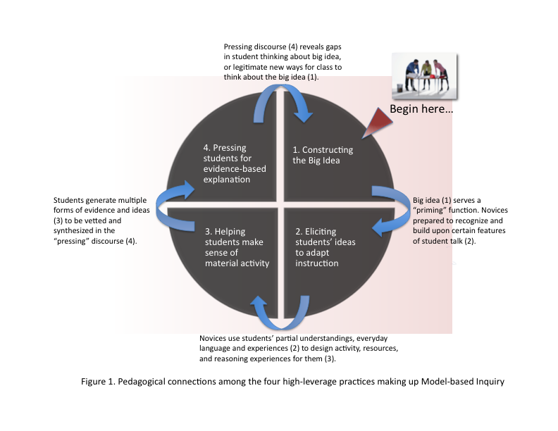
Another intentional design feature was to represent teaching in ways that could not be easily linked to unproblematic theories that beginners often use to think about instruction, such as cycles of lecture-lab-lecture-lab-test, or The Scientific Method. We wanted to make it difficult for participants to “layer” their existing ideas about organizing instruction onto our Science Learning Framework, and discourage them from glossing over strategic planning and instructional moves built into each of the component practices. In other words, we intended to frame-shift how our participants thought about organizing instruction, and foster new visions of good teaching.

The first of these HLPs is a planning practice referred to as Constructing the Big Idea. The remaining three are enactment practices that we frame as discourses rather than behavioral routines or even lessons. These are: Eliciting Students’ Ideas to Adapt Instruction, Helping Students Make Sense of Material Activity, and Pressing Students for Evidence-Based Explanations. For each of these four practices we developed a tool that guided participants’ planning, enactment and reflection upon lessons.

Constructing the Big Idea
We believed that designing a tool for constructing a big idea—one that encouraged the same kind of thinking that expert educators invoke in planning units of instruction—would be crucial in supporting the development of this HLP.

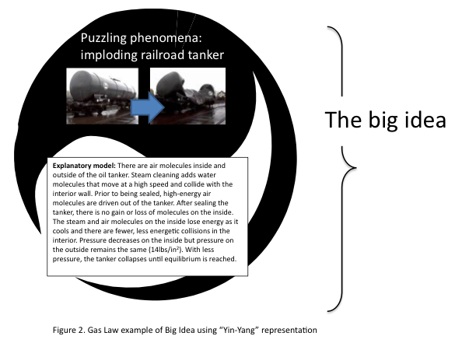
This planning practice was promoted as the first step in any unit of instruction. The tool we designed—referred to here simply as the Big Idea Tool— was intended to help participants develop an explicit and elaborate understanding of the target ideas they intended to teach, and to do so in terms of explaining a natural phenomenon that students could relate to. The tool is purposely low-tech, consisting of an electronic document in which participants can type in responses to a series of prompts and that can be revised as new ideas come to light. The tool begins with our description of “what counts” as a scientific idea worthy to build a unit around. We wanted to discourage the notion that a big idea could be captured in a single word or phrase like “heredity”, “force and motion,” or “the seasons.” Instead, we portrayed big ideas as relationships between some natural phenomenon and its underlying causal explanation. This underlying explanation had to include unseen processes or events that helped tell a story of why the phenomenon unfolds as it does. We used the Taoist Yin-Yang symbol to illustrate the conjoined nature of the relationship and asked participants to write or draw their phenomenon and explanation into the upper and lower halves of the symbol. Figure 2 is an example of the big idea for a Gas Laws unit, in which the puzzling phenomenon is a railroad tanker car that imploded after being steam cleaned. The explanatory model is fully elaborated below, combining the observable (heated steam, rapid implosion, etc.) and the unobservable (molecules of different types inside and outside the tanker moving at different speeds, creating collisions with the walls of the structure).

The latter part of the tool scaffolded the kinds of thinking that more experienced teachers engage in when trying to locate fundamental ideas of importance within common curriculum topics—ideas that are actionable in terms of designing instruction. Step 1 directs participants to find different resources that can help them more deeply understand whatever phenomenon, concept, or theme is listed in the curriculum, and locate links to the topic in various standards documents.

Step 2 is a series of prompts that assist the participant in translating curriculum topics from vague labels to big ideas, depending upon how the curriculum framed the topic. Put another way, we asked participants to “unpack” ideas whose importance is often assumed to be self-evident. This an example of exercising a teacher’s specialized content knowledge. Specialized content knowledge is a term used by Ball, Thames, and Phelps (2008) to describe understandings of subject matter that go beyond what experts in the disciplinary fields (in this case science or engineering) would normally need to carry out their work. For example, if the curriculum lists tangible entities as the topic (batteries and bulbs, acids and bases, plants, types of rocks), the participant responds to the questions: “Should details and facts about these ‘things’ be the target of study, or are there more fundamental processes associated with these things that kids should understand?” “Are these things worth studying because they are part of a larger system of activity?” and “What aspects of these things might be relevant to kids’ lives?”

In Step 3 participants select some rich phenomenon that their students can attempt to explain over a period of days. This could be anything from earthquakes to patterns of heredity. They then articulate the underlying explanatory model with its unobservable cast of characters and its causal processes. This model depicts a full storyline for the observed phenomenon.

In Step 4 they are asked to consider what success looks like if students understand this big idea. Here they identify new phenomena that the underlying model in the big idea could also explain. They are asked to imagine “what if” scenarios or thought experiments that students could predict outcomes for.

We hypothesized that clarifying the big idea using this tool would help participants construct learning goals in terms of both concepts and performances. We believed it would help participants understand the component concepts of the big idea, the possible sequencing of these concepts, and the bodies of first and second-hand evidence that students must become familiar with if they are to accomplish a culminating performance.

We further hypothesized that teachers reasoning with and about the subject matter in this way would serve a priming function. By priming we mean that in the process of planning, teachers explicitly surface the details not only of the target explanation, but also of the associated ideas and language that students might draw upon to make sense of these targets. Priming we thought could prepare teachers for classroom dialogue, to recognize traces of these partial understandings in students’ talk and to have considered ahead of time how to respond productively as students explore science ideas. In other words, we planned for the tool to expand the range of what novices recognize as student contributions that could be built upon or challenged in particular ways, rather than dismissed as irrelevant. Priming could not only focus the teacher’s anticipation for student contributions, but more broadly contribute to an organized framework for listening.

The Role of Discourse in Science Teaching and Learning
While it may seem intuitive to focus on the abilities of the teacher to design and manage activities for students, recent scholarship has emphasized that meaningful learning is a product not of material activity, but of sense-making discourse aimed at developing conceptual understanding and the links between theory and observable phenomena (Mortimer & Scott, 2003). Michaels, O’Connor, and Resnick (2008) claim that “sense making and scaffolded discussion, calling for particular forms of talk, are seen as the primary mechanism for promoting deep understanding of complex concepts and robust reasoning” (p. 284). In this view, learning is not accomplished through the transmission of knowledge from person to person, or the unproblematic uptake of ideas from hands-on activity, but rather through an ongoing process of comparing one’s own understandings with those that are being rehearsed on the social plane of the classroom (Herrenkohl & Guerra, 1998; O’Connor & Michaels, 1996).

Dialogue in conjunction with material activity also engages learners in the canonical practices of science— that is, “to formulate questions about phenomena that interest them [students], to build and critique theories, to collect, analyze and interpret data, to evaluate hypotheses through experimentation, observation, measurement, and to communicate findings” (Rosebery, Warren & Conant, 1992, p. 65). These forms of discourse are rare, even in the classrooms of experienced teachers (Banilower, Smith, Weiss, and Pasley, 2006; Horizon Research International, 2003; Roth & Garnier, 2007; Weiss, Banilower, McMahon, & Smith, 2001). Despite this, we felt that with specially designed tools and other forms of assistance, novices could develop ways to support several important forms of discourse with their students.

We constructed outlines for a set of three discourses to serve as the remaining HLPs. Indentifying specific patterns of conversation and then parsing out the intellectual work necessary to participate in such talk is part of what Grossman et al. (2009) refer to as “decomposing” instructional acts, that is, “breaking down complex practice into its constituent parts for the purposes of teaching and learning” (p. 8). Each of the three discourses included aspects of planning, enactment, and reflection. Each was supported by a tool which explained the purposes of that discourse, situated it within the larger Science Learning Framework, and provided a template for a series of teacher-student or student-student exchanges that would ideally accomplish the goals of the overall conversation. These sample exchanges were developed by an analysis of expert teacher conversations from the literature and from our own backgrounds as experienced educators. Each page in the tool containing the sample dialogue also included, in a left hand margin, pre-planning questions for the participants to answer in anticipation of enacting this discourse in simulations held during the methods course or during student teaching (Figure 3 shows a page from the discourse tool: Helping Students Make Sense of Material Activity). In the right hand margins, are a parallel series of reflection questions to be answered after they had enacted the discourse with peers or with secondary students.

We recognize that encouraging student discourse in classrooms is not a guarantee that equitable teaching is happening, however we have integrated the following ideas into the tools and the ways that we have talked about instruction with our pre-service teachers:
• Instruction is centered around phenomena that are relevant and apprehensible to young learners, as are the essential questions that guide instruction.
• Student’s everyday language and experiences are framed as resources to be capitalized on when making instructional decisions.
• The accompanying tools and other resources we’ve developed (videos, discourse primer document) provide strategies for and examples of hearing a wider range of student voices in the classroom.
• The discourses emphasize high expectations for all kids and demand teacher attention to those students who may not be participating.

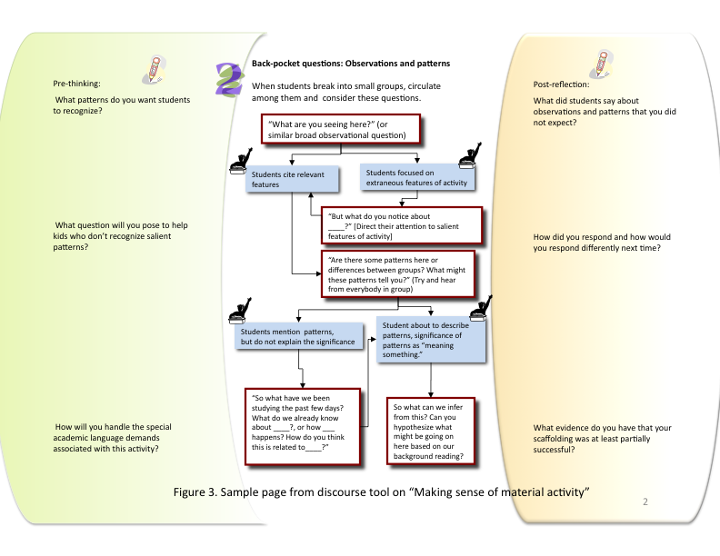
The following sections describe the three discourses in more detail.

Eliciting students’ ideas to adapt instruction.
The goal of this discourse is to elicit students’ understandings of a phenomenon (e.g. a bicycle rusting in the backyard) that is related to an important scientific idea (in this case chemical change or conservation of mass) and then to analyze students’ ways of talking about it in order to adapt upcoming instruction. Among the components of this practice are: planning beforehand a rich task that can reveal a broad range of student thinking on the target big idea; eliciting observations from students about a phenomenon of interest to them and encouraging students to offer initial causal hypotheses about the phenomenon (the questions and tasks in this practice emerge from the big idea planning), assisting students in synthesizing what they think they know and what they want/need to know, and after class, analyzing students’ contributions to shape instruction. The latter part of the tool supports an analyses of:
• students’ partial understandings of the target ideas
• students’ alternative conceptions about the target ideas
• students’ everyday language that can be leveraged to help them understand scientific language related to the target idea
• students’ everyday experiences related to the target idea that can be leveraged in later instruction.
The trends emerging from this analysis are then used to make decisions about how to “work on students’ ideas” in subsequent lessons (a practice we reinforce as what all good teachers do).

Helping students make sense of material activity.
The goal of this practice is to combine hands-on work with readings and conversation in order to build content knowledge and advance students’ understanding of a natural phenomenon. This practice is designed to be enacted multiple times in a unit of instruction— repeated iterations of reading or presenting of new ideas, sense-making conversations, and using students’ new understandings to further instruction. This practice is composed of three parts, the second of which involves a discourse tool.

First, what is judiciously presented to students through teacher-led discussions or media are some features of the big idea (in the form of a scientific model) that are not directly observable. In other words, underlying events, processes and entities that would help students understand some aspect of the observable world, but are not “discoverable” through exposure to material activity or data (via experiments, demonstrations, lab activities, etc.). Following this building of background knowledge comes an activity in which students use partial knowledge of the unobservable/theoretical processes to make sense of observations generated from hands-on work or from second hand data. The sense-making discourse takes place during and after this activity. The goals are of this multi-part discourse are to:
• help students understand how the activity relates to a scientific question or idea they have been puzzling over,
• assist students in bridging the observations or data collected during the activity with a larger scientific idea and,
• support the development of students’ academic language as a resource for communicating concepts and making sense of scientific ideas within the classroom community.

Following rounds of hands-on work and sense-making conversations, the teacher re-visits with students their previous hypotheses and partial understandings. The teacher takes stock of students’ new understandings and uses this information to plan further lessons.

Pressing students for evidence-based explanations.
The goal of this discourse is to assist students in co-constructing evidence-based explanatory models for the natural phenomenon that have been the focus of the unit. These models depict, in words and drawings, a chain of reasoning linking observations and information from a variety of sources students have had experiences with (first-hand data, second-hand data, information resources, known facts, concepts, laws, etc.) with unobservable (underlying) events, structures, or processes. The phenomenon being explained could be the focus of a model-based inquiry that students have engaged in over the previous few days (e.g. Why do pulleys help us lift heavy loads?), or a puzzling situation for which students have primarily second hand data (e.g. Why asthma is so prevalent in poor urban communities?).

This conversation usually comes after the teacher has allowed students to create some initial models of the key phenomenon, given them some data collection experiences, and exposed them to important written resources to aid their conceptual understanding. This discourse is designed to happen at the end of a unit, but elements of this conversation can also happen when the teacher is trying to get students to talk about evidence.

We typically extend this discourse over multiple conversations, and it plays out over at least two class periods. It follows this general pattern: re-orienting students to the possible explanatory models and hypotheses that could have been proposed up to this point, coordinating students’ tentative explanations with available evidence, committing an explanation to paper, prompting students to talk about the strength of the evidence and the reasoning that links evidence with explanations, writing a final explanation, and having students apply the new explanatory model in contexts beyond those discussed in class.

As mentioned previously, these HLPs act as coherent practices and they can be used together to plan for units of instruction. Figure 4 shows how we break out the HLPs to facilitate such multi-lesson planning.
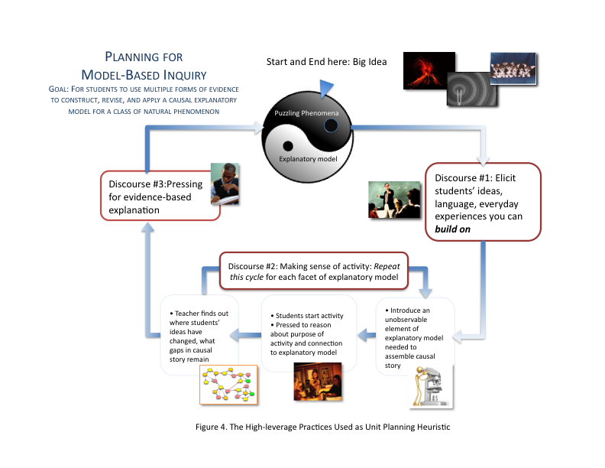
Can High-Leverage Practices Be Taught To And Learned By Novices?
Two important criteria for HLPs are that they be conceptually accessible to novices, and that they can be taught and learned. Although this testing phase of our research is just beginning, we can share some early findings. Our current cohort of seventeen pre-service teachers have been through two quarters of our methods class in which all four HLPs were introduced, modeled by the instructor, portrayed in videos of two different secondary school classrooms, and practiced by the teacher candidates themselves. These participants have also been through two field experiences in local high-needs schools in which they have both observed instruction and had extensive interactions with young learners in small group situations.

We have strong evidence that participants are able to use the big idea tool to re-think common curriculum topics and that they believe this intellectual work is a potentially productive way to design instruction. Participants have taken topics like earthquakes, homeostasis, and Gas Laws and identified more fundamental underlying ideas that make these topics worth teaching. Kinetic molecular theory, for example, was identified by several participants as being foundational to understanding why the Gas Laws hold true. Furthermore, we believe they are internalizing “big ideas” as relationships between observable phenomena and the unobservable entities and processes that help explain how everyday occurrences happen. We believe this because participants are using the concept of big ideas as a lens to view teacher decision-making the classrooms they are visiting. One participant, during a two-week observation period in a local school, described a conversation with a biology teacher about the aims of her unit on the human circulatory system. The teacher’s goal was to have students draw out the pathways of blood circulation in the body. The observing teacher candidate noted, however, that the students did not know the reason for the evolution of these particular pathways, and that having an explanatory model consisting of unobservable entities like oxygen and unobservable processes like cellular respiration would have helped students construct the “why explanations” they would have needed to make sense of the circulatory processes. This participant wrote in an assignment for a class other than our methods class: “As a teacher, I cannot give my students the “middle of the story”; (the individual pieces of information), and expect them to connect it to the beginning (observable phenomena) and ending (the underlying purpose of these details)…” [parenthetical text in original]. In the first unit they designed to teach in their own practicum classrooms, almost all of them have gone beyond the topics listed in their curriculum and used the explanatory model in the Yin-Yang diagrams to organize more substantive learning opportunities for their students.

With regard to the three discourses, most participants have begun to view classroom activity as patterns of dialogue rather than as repeated cycles of “lecture-lab-worksheet- test.” Participants have taken up the language embedded in the discourse tools around “probing”, “pressing”, and “high-cognitive demand questions.” During the simulated teaching episodes that participants planned and enacted with peers, they were able to use the discourse tools to create cohesive lessons, although we would classify their initial attempts as “clunky implementation.” For example, the fourth high-leverage practice—pressing students for evidence-based explanations—was unlike any science conversation most of them had ever experienced as learners. They struggled somewhat in conceiving of “what counted” as evidence for a particular explanation.

Because eliciting and responding to student thinking is explicitly built into the discourse tools, all our participants were able to attend to ideas of their simulated “students”, albeit to various degrees. Attending to student thinking is considered a skill that develops only after significant time in the classroom (see Berliner, 2001; Carter, Cushing, Sabers, Stein & Berliner, 1988). Our study however and other recent work (Levin, Hammer, & Coffee, 2008) have shown that novices are quite capable of this if given tools and support.

We note here that for any reader who imagines these discourse tools as an effort to hyper-normalize early practice, we can assure them that these participants’ teaching simulations were each unique and imaginative. Even when given the same topics to teach, such as homeostasis, their instruction focused on ideas as different as cellular osmosis and ecosystem imbalances. Their questioning, although guided by the tool, was spontaneous, adaptive to their “students” responses and for the most part, at least partially successful in accomplishing the goals of the discourse.

At a broader level of analysis, we see that participants can implement these multi-step practices, but they initially tend to abstract from them only a gestalt vision of the interactions between teacher and students. That is, even though they can craft rich tasks to elicit learners’ initial ideas about a scientific phenomenon and asking a variety of probing questions, they cannot recall the differentiated levels of questioning that we’ve built into the first discourse tool—the kinds of strategic succession of question types that demark experts from less accomplished teachers. We see too that the labor-intensive discourse tools cannot be used when they move from student teaching to their first year of professional work. We will need to craft more streamlined versions of these for our participants, hoping that they will, by that time, have a richer understanding of the practices and that they will have internalized the key steps of preparing for instructional conversations and reflecting later on students’ participation in this talk. Perhaps the scaled-down tool will be merely an outline of question types that guide a lesson, while retaining the crucial features of the practice that make it “high-leverage.”

Importantly there were three unexpected events that have come out of these attempts at high leverage practices and the use of the tools. First, in the months following the initial methods instruction, participants were working with students in an urban high school summer program. They were collectively assisting a teacher in her attempts to get these young learners to use evidence in constructing explanations. Two of our participants suggested using the discourse tool with the students and in preparation for doing this, they reinvented parts of the tool. In doing so they recognized when the tool and discourse should be used, and they understood how the tool could be modified to make it more productive given the instructional context and needs of the students. They then successfully engaged several classes of students in this explanatory discourse—all without the assistance or prompting of the university faculty.

Second, a number of our participants have spontaneously referred to the tools as prioritizing “equity discourse” in their classrooms. This indicates that they do not see rigorous science and equitable science as two different conversations.

Third, what has made the value of these tools and the practices they represent more apparent to our participants is not the design of the tools themselves, nor our modeling of the instruction. Rather it is the repeated exposure to young students’ conversations about scientific ideas as shown in our videos and during our visits to local schools. In the videos we strategically kept the cameras on groups of students, even after the teacher had moved to another part of the classroom. Although these segments did not show a strategy by the teacher, it revealed to our participants a range of thinking by students that most of them had never imagined. Our participants were at times surprised by patterns of reasoning exhibited by students, who earlier in the video appeared to be clueless about the science ideas. At other times our participants were puzzled by students who apparently had “right answers” for the teacher in small group questioning, but when their thinking was probed further, revealed profound misconceptions. During one visit to a local high-needs school we seated participants at tables with students who were trying to make sense of a buoyancy activity they had done the day before. Our beginning teachers marveled at the intellectual effort kids were willing to expend on understanding an idea and the richness of their thinking. The opportunity for these novices to listen to kids’ talk about non-routine tasks and to occasionally try out probing and pressing questions with them, helped them see that such opportunities for productive types of discourse were going to be essential in their own classrooms. As other researchers have noted, a major barrier to ambitious instruction for beginning teachers is that they have little idea what students are capable of (Elmore, 2005). The video and school visits served to re-calibrate these expectations. Whether they continue to value pressing students for high-quality work and if they are capable of engaging in such teaching activity is yet to be seen.

Finally, an important part of this story would be missing if we failed to talk about the impact of this process on us, the faculty, post-doctoral researchers, and doctoral students who developed these tools and learning experiences. The prospect of deciding what kinds of practices were valuable enough to feature in our framework, compelled us to focus on questions we had never confronted as a group: “What are the most important kinds of learning that can happen in a secondary science classroom?” “How do the best teachers help all kids learn challenging material?” We then deconstructed our chosen set of core practices to make visible what is important in them. In the end, we had to be brutal about cutting out any form of practice that would not directly address the kinds of student learning opportunities we thought were important. We did not for example address as stand-alone topics things like project-based learning, experimental design, planning for field trips, group work, reading in the content area, or classroom management. Many elements of these were addressed, but within the context of the four HLPs.

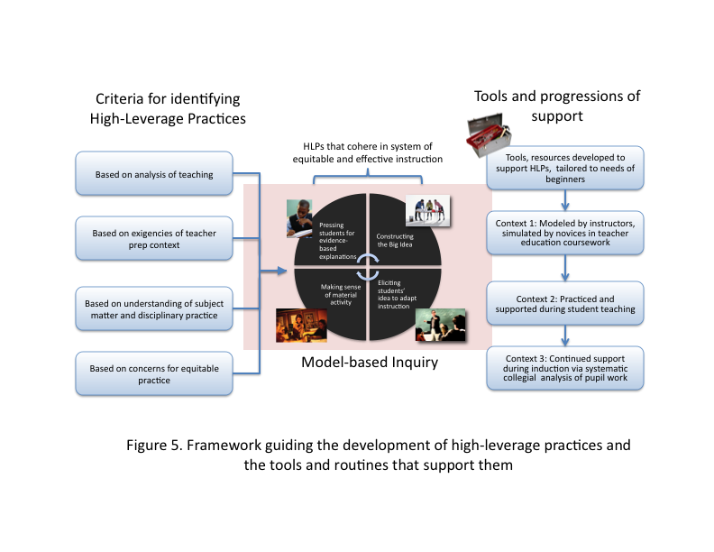
Only in hindsight can we now look back on the former design of the methods course, taught for the past twelve years, and recognize the well intentioned but scattered nature of topics we addressed. Through this re-organization of course experiences around the HLPs, we have achieved a new clarity about what the performance goals are for participants, we have little ambiguity about how to assess where our participants are in their trajectories toward competent practice, and we know what kinds of support our participants will need in the field (Figure 5). The accessibility and coherence of this conceptual framework has been noted many times by participants themselves, who despite the unusually high expectations placed on them, understand clearly what kinds of performances they are aspiring to and can see how all parts of their preparation experience converge in the Science Learning Framework. We believe this accessibility and internalizing of many of our HLP ideas is because we are focusing on practices of demonstrably high value to our participants. Although we and they have been guided by overarching goals and standards, it has been the tools’ clear links with instructional activity that has made the ideas embodied in them more actionable by participants.

A Final Word About The Beginners Repertoire
Our argument here has been: If sets of high-leverage practices for different subjects matter areas could be articulated and taught across early learning-to-teach contexts, the broader teacher education community could collectively refine these practices as well as tools and other resources that support their development. Without an identifiable set of core practices to anchor instruction by both teacher educators and beginning teachers, improvement in instruction will continue to be isolated, individual, and haphazard. Core practices could become the basis for the design of tools (like ours) for novices, tools for K-12 students to engage in the practices themselves, and resources such as classroom case studies in video form, along with educative samples of pupils’ performances and written work. A set of core practices could support more coherent inquiries by teacher interns, their cooperating teachers and departmental colleagues into student learning—this support would come in the form of shared conceptions and a common language around particular practices. By extension, mentoring of novices during the induction years could be grounded both in conversations about practices and in student learning. A set of core practices could be represented along the spectrum of effective implementation—essentially portrayed as a set of performance progressions for teachers to locate their current practice in pedagogical space, envision what the next level of performance might look like, and identify moves and tools to take their practice in that direction. This is already happening in teacher education (Furtack, Thompson, & Windschitl, in press).

We acknowledge the controversial nature of this proposal. There are no ideal forms of high-leverage practices, but rather there are instructional enactments that assist novices in achieving important teaching and learning goals with more success and consistency than others. Failure to make hard choices about preparing teachers would leave us with our current state of affairs—an eclectic assortment of programs in which individual practitioners’ developmental trajectories cannot be supported by clear standards and a profession which is less able to systematically improve its instructional mission. We recognize too that any proposal for prioritizing instructional practices in our teacher preparation system will be heavily scrutinized, given that no such subset can fully support the development of effective, caring, and reflective practitioners. And, that the choices reflect values about the orientation towards teaching that may not be part of the vision that many teacher educators use currently to guide their practice. Our aim here is not some form of technical reductionism, but rather the continued professionalism of science teaching. As our research group continues to gather data and refine our systems of support, we will gain a clearer picture of the promise and the pitfalls of focusing on high-leverage practices as a way to improve the performance of the next generation of teachers and the evolution of teacher education.

Footnotes
¹Much of how we think about the development of teacher reasoning and practice has been framed by novice-expert dichotomies (Berliner, 1994; Carter, Cushing, Sabers, Stein, & Berliner, 1988; Lin, 1999) and by stage theories (Dreyfus & Dreyfus, 1986). Stage theories, however, do not tell us much about why novices differ in their early skill development, about the characteristics of the learning experiences that may help teachers acquire initial craft knowledge (Berliner, 2001), or even attain competence as they exit teacher preparation (Darling-Hammond, 2000; Hammerness and others, 2002; Koppich, 2000).

²Although this list was developed for K-8 learners, we see no reason these proficiencies are not applicable to secondary and undergraduate learners.

References

Adams, P. E., & Krockover, G. H. (1997). Beginning science teacher cognition and its origins in the preservice secondary science teacher program. Journal of Research in Science Teaching, 34, 633-653.

Anderson, C., Sheldon, T. & Dubay, J. (1990). The effects of instruction on college non
majors’ conceptions of respiration and photosynthesis. Journal of Research in Science Teaching, 27, 761-776.

Ball, D. L., Thames, M. H., & Phelps, G. (2008). Content knowledge for teaching: What
makes it special? Journal for Teacher Education, 59(5), 389 – 407.

Ball, D. L., Sleep, L., Boerst, T., & Bass, H. (2009). Combining the development of practice and the practice of development in teacher education. Elementary School Journal, 109(5), 458–474.

Banilower, E., Smith, P. S., Weiss, I. R., & Pasley, J. D. (2006). The status of K-12 science teaching in the United States: Results from a national observation survey. In D. Sunal & E. Wright (Eds.) The impact of the state and national standards on K-12 science teaching, pp. 83-122. Greenwich, Connecticut: Information Age Publishing.

Berliner, D.C. (1994). Expertise: The wonder of exemplary performances. In J. Mangieri and C.C. Block (Eds.), Creating powerful thinking in teachers and students: Diverse perspectives (pp. 161-186). Fort Worth, TX: Harcourt Brace College Publishers.

Berliner, D.C. (2001). Learning about and learning from expert teachers. International Journal of Educational Research, 35(5), 463-483.

Bryk, T. (2009). Supporting a science of performance improvement. Phi Delta Kappan, 90(8), 507-600.

Carter, K., Cushing, K., Sabers, D., Stein, P. and Berliner, D. (1988). Expert-novice
differences in perceiving and processing visual classroom information. Journal of
Teacher Education, 39(3), 25-31.

Clift, R. T., & Brady, P. (2005). Research on methods courses and field experiences. In M. Cochran-Smith & K. Zeichner
(Eds.), Studying teacher education (pp. 309–424). Mahwah, NJ: Erlbaum.

Darling-Hammond, L. (Ed.). (2000). Studies of excellence in teacher education, (3
volumes). Washington, DC: American Association of Colleges for Teacher
Education.

Davis, E. A., Petish, D., & Smithey, J. (2006). Challenges new science teachers face. Review of Educational Research, 76(4), 607-651.

Dreyfus, H. L. & Dreyfus, S.E. (1986). Mind over machine. New York: Free Press.

Duschl, R. (1983). The elementary level science methods course: Breeding ground of an apprehension toward science? Journal of Research in Science Teaching, 20, 745-754.

Elmore, R. (2005, February). Our best ideas about instructional practice do not operate at scale. Presentation given at NSF K-12 Math, Science, and Technology curriculum Developers Conference. Washington DC. Feb. 27th.

Fennema, E., Franke, M. L., Carpenter, T. P., & Carey, D. A. (1993). Using children’s mathematical knowledge in instruction. American Educational Research Journal, 30(3), 555–583.

Franke, M. L., & Chan, A. (2007, April). Learning about and from focusing on routines of practice. Paper presented at the annual meeting of the American Educational Research Association, Chicago.

Freese, A. R. (2006). Reframing one’s teaching: Discovering our
teacher selves through reflection and inquiry. Teaching and Teacher
Education, 22, 100-119.

Furtak, E. Thompson, J. & Windschitl, M. (in press). Learning progressions to support teacher
development. In A. Gotwals & A. Alonzo (Eds.) Learning progressions in science education.

Gallagher, J. (1991). Prospective and practicing secondary school science teachers’
knowledge and beliefs about the philosophy of science. Science Education, 75, 121 133.

Gess-Newsome, J. & Lederman, N. (1993). Pre-service biology teachers’ knowledge
structures as a function of professional teacher education: A year-long assessment. Science Education, 77, (1), 25-46.

Grossman, P., Compton, C., Igra, D., Ronfelt, M., Shahan, E., & Williamson, P. (2009). Teaching practice: A cross-professional perspective. Teachers College Record, 111(9).

Grossman, P., & McDonald, M. (2008). Back to the future: Directions for research in teaching and teacher education. American Educational Research Journal, 45(1), 184–205.

Hammerness, K., Darling-Hammond, L., and Shulman, L. (2002, April 10-14). Towards expert thinking: How curriculum case-writing prompts the development of theory-based professional knowledge in student-teachers. Teaching Education (13)2, 219-225.

Herrenkohl, L. R., & Guerra, M. R. (1998). Participant structures, scientific discourse, and student engagement in fourth grade, Cognition and Instruction, 16, 433-475.

Hiebert, J., Gallimore, R., & Stigler, J. W. (2002). A knowledge base for the teaching profession: What would it look like and how can we get one? Educational Researcher, 31(5), 3–15.

Hill, H. C., Rowan, B., & Ball, D. L. (2005). Effects of teachers’ mathematical knowledge for teaching on student achievement. American Educational Research Journal, 42, 371-406.

Horizon Research International. (2003). Special tabulations of the 2000-2001 LSC teacher questionnaire and classroom observation data. Chapel Hill, NC: Horizon Research.

Koppich, J. (2000). Trinity University: Preparing teachers for tomorrow’s schools. In L. Darling-Hammond (Ed.), Studies of excellence in teacher education: Preparation in a five-year program (pp. 1-48). Washington, DC: American Association of Colleges for Teacher Education.

Lampert, M., & Graziani, F. (2009). Instructional activities as a tool for teachers’ and teacher educators’ learning. Elementary School Journal, 109(5), 491–509.

Lee, C. (2007). The role of culture in academic literacies: Conducting our blooming in the midst of the whirlwind. New York: Teachers College Press.

Levine, A. (2006). Educating School Teachers. Washington DC: Education Schools Project. Retrieved July 10, 2009 from http://www.edschools.org/teacher_report_releaase.htm.

Levin, D., Hammer, D., & Coffee, J. (2008). Novice Teachers' Attention to Student Thinking. Journal of Teacher Education, Vol. 60, No. 2, 142-154.

Lin, S. J. (1999, March). Looking for the prototype of teaching expertise: An initial
attempt in Taiwan. Paper presented at the Annual Meeting of the American
Educational Research Association, Boston.

Michaels, S., O'Connor, C., & Resnick, L. (2008). Reasoned Participation: Accountable Talk in the Classroom and in Civic Life. Studies in Philosophy and Education. 27 (4): 283-297. Read more: http://www.clarku.edu/academiccatalog/facultybio.cfm?id=15#ixzz0KPZQlrC9&C

Morris, A. K., & Hiebert, J. (2009). Introduction: Building knowledge bases and improving systems of practice. Elementary School Journal, 109(5), 429–441.

Mortimer, E. & Scott, P. (2003). Meaning making in secondary science classrooms.
Philadelphia: Open University Press.

National Research Council. (1996). National science education standards. Washington, DC: National Academy Press.

National Research Council. (2000). Inquiry and the National Science Education Standards. Washington, DC: National Academy Press.

National Research Council (2005). America’s Lab Report: Investigations in High School Science. Committee on High School Laboratories: Role and Vision. Susan R. Singer, Amanda L. Hilton, and Heidi A. Schweingruber, Eds. Board on Science Education. Center for Education, Division of Behavioral and Social Sciences and Education. Washington, DC: National Academies Press.

National Research Council (2007). Taking Science to School: Learning and Teaching Science in Grades K-8. Committee on Science Learning, Kindergarten Through Eighth Grade. R. A. Duschl, H. A. Schweingruber, and A. W. Shouse (Eds.). Board on Science Education, Center for Education, Division of Behavioral and Social Sciences and Education. Washington, DC: The National Academies Press.

Newmann, F., & Associates. (1996). Authentic achievement: Restructuring schools for intellectual quality. San Francisco: Jossey-Bass.

Nolen, S. B., Ward, C. J., Horn, I. S., Childers, S., Campbell, S., & Mahna, K. (forthcoming). Motivation in preservice teachers: The development of utility filters. In M. Wosnitza, S. A. Karabenick, A. Efklides & P. Nenniger (Eds.). Contemporary Motivation Research: From Global to Local Perspectives. Ashland, OH: Hogrefe & Huber.

O’Connor, M. C., & Michaels, S. (1996). Shifting participant frameworks: Orchestrating thinking practices in group discussion. In D. Hicks (Ed.), Child discourse and social learning (pp. 63–102). Cambridge: Cambridge University Press.

Pomeroy, D. (1993). Implications of teachers’ beliefs about the nature of science:
Comparisons of the beliefs of scientists, secondary science teachers, and elementary science teachers. Science Education, 77, 261-278.

Rosebery, A. S., Warren, B., & Conant, F. R. (1992). Appropriating scientific discourse: Findings from language minority classrooms. Journal of the Learning Sciences, 2(1), 61-94.

Roth, K. & Garnier, H. (2007). What science teaching looks like: An international perspective. Educational Leadership, 64(4), 16-23.

Sanders, M. (1993). Erroneous ideas about respiration: The teacher factor. Journal of
Research in Science Teaching, 30, 919-934.

Smith, J., Lee, V., & Newmann, F. (2001). Instruction and achievement in Chicago elementary schools. Chicago: Consortium on Chicago School Research, Chicago Annenberg Research Project.

Thompson, J. Windschitl, M. & Braaten, M. (April 2009). How Pedagogical Reasoning and Ambitious Practice Develops Across “Learning to Teach” Contexts. Annual conference of the National Association of Research in Science Teaching. Anaheim, CA.

Yackel, E., & Cobb, P. (1996) Sociomathematical norms, argumentation, and autonomy in mathematics. Journal for Research in Mathematics Education, 27(4), 458-477.

Warren, B., & Rosebery, A. S. (1996). “This question is just too easy!” Students’ perspectives on accountability in science. In L. Schauble & R. Glaser (Eds.), Innovations in learning: New environments for education (pp. 97–125). Mahwah, NJ: Lawrence Erlbaum Associates.

Weiss, I. R., Banilower, E. R., McMahon, K. C., and Smith, P. S. (2001). Report of the
2000 National Survey of science and mathematics education. Horizon Research Inc. Available at www.horizon-research.com.

Westbrook, S. & Marek, E. (1992). A cross-age study of student understanding of the
concept of homeostasis. Journal of Research in Science Teaching, 29, 51-61.

Windschitl, M. Thompson, J., & Braaten, M. (forthcoming) Ambitious Pedagogy by Novice
Teachers? Who Benefits From Tool-Supported Collaborative Inquiry into Practice and Why. Teachers College Record.

Zeichner, K. and Tabachnick, R. (1981). Are the effects of university teacher education ‘washed out’ by school experience?’ Phi Delta Kappan, 32 (3), -11.

