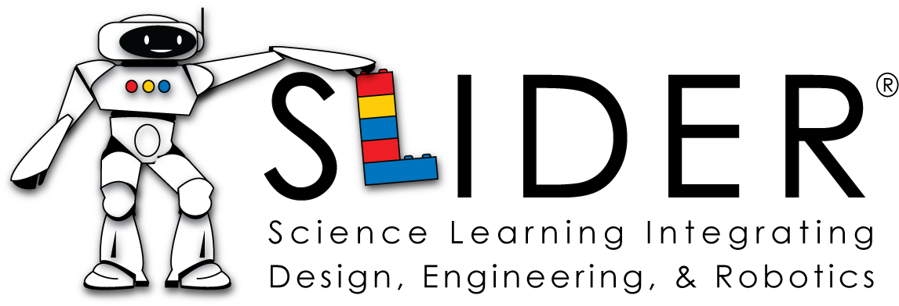

Science Learning Integrating Design, Engineering, and Robotics (SLIDER)
Dr. Richard Millman, Director of the Center for Education Integrating
Science, Mathematics, and Computing (CEISMC)
Dr. Cher Hendricks, CEISMC

Overview. The purpose of SLIDER is to develop and implement a rigorous 8th grade physical science program that uses engineering design, LEGO robotics, and LEGO mechanics to teach physics-based science concepts. The program is a collaborative effort among K12 educators, university faculty, and educational outreach specialists in Georgia Tech’s Center for Education Integrating Science, Mathematics, and Computing (CEISMC). The SLIDER team includes learning theory and cognitive sciences professionals from:

- Georgia Tech’s Center for the Enhancement of Student Learning, School of Psychology, School of Biomedical Engineering, and College of Computing;
- Georgia Department of Education; and
- three Georgia school systems.

Using backward design strategies, the SLIDER curriculum development team at CEISMC is creating inquiry-based engineering design instructional materials that align with the Georgia Performance Standards (GPS) and employ contextualized, problem-based challenges that require students to design, investigate, reflect on, and then revise their product or solution. Materials will provide modules in mechanics (force, motion, simple machines), waves (light, sound, magnetism, electricity, heat), and energy and will utilize LEGO Robotics.

Research Questions. In this project, we ask (a) formative questions related to teacher professional development and assessment of learning outcomes and (b) summative questions focused on student learning, motivation, engagement, and interest in STEM fields:

- To what extent can research-based physical science instructional materials that use problem-based, inquiry learning in the context of engineering design scenarios empower a broad range of middle school students to learn physical science content and reasoning skills?

- To what extent can these instructional materials lead to increased engagement, motivation, creativity, and interest in STEM fields, and how does this effect persist as students move into high school?

- To what extent do students engage with the materials differently depending upon their gender, race, socioeconomic status, prior achievement level, and location (urban, suburban, rural)?

- How should the learning that takes place best be assessed in the classroom, and how does this assessment impact student performance?

- What type of support, both in instructional materials and professional development, is necessary to adequately prepare teachers to deliver this type of curriculum?

Research Design. In our current research plan, which is still under development, we use mixed methods to answer our research questions:

For our first and second questions, which focus on student outcomes, we will use subjects as their own controls to determine changes in science achievement, engagement, motivation, creativity, and interest in STEM fields. We have access to student grades and scores on statewide achievement tests for the years prior, during, and after students complete the 8th grade SLIDER program. We are currently pilot-testing instruments to measure student engagement, motivation, creativity, and interest in STEM. These instruments will be given during the 7th, 8th, 9th, and 10th grade years.

To determine differences in student engagement, we will rely on (a) classroom observations, (b) observations by teachers and teacher report, and (c) surveys, interviews, and focus groups with students.

We are in the process of determining how best to answer our final two research questions. Because these questions focus on teacher professional development (PD), we plan to collect data throughout teacher training sessions (through observations and by having teachers complete evaluations of the professional development) and use the results to improve future PD training. We are documenting this process as we go.

Participating Schools and Teachers. Three schools are participating in SLIDER: one rural, one urban/suburban, and one suburban. School data are provided in Tables 1 and 2.

Tables 1 and 2. Demographics and Academic Performance of Participating Schools
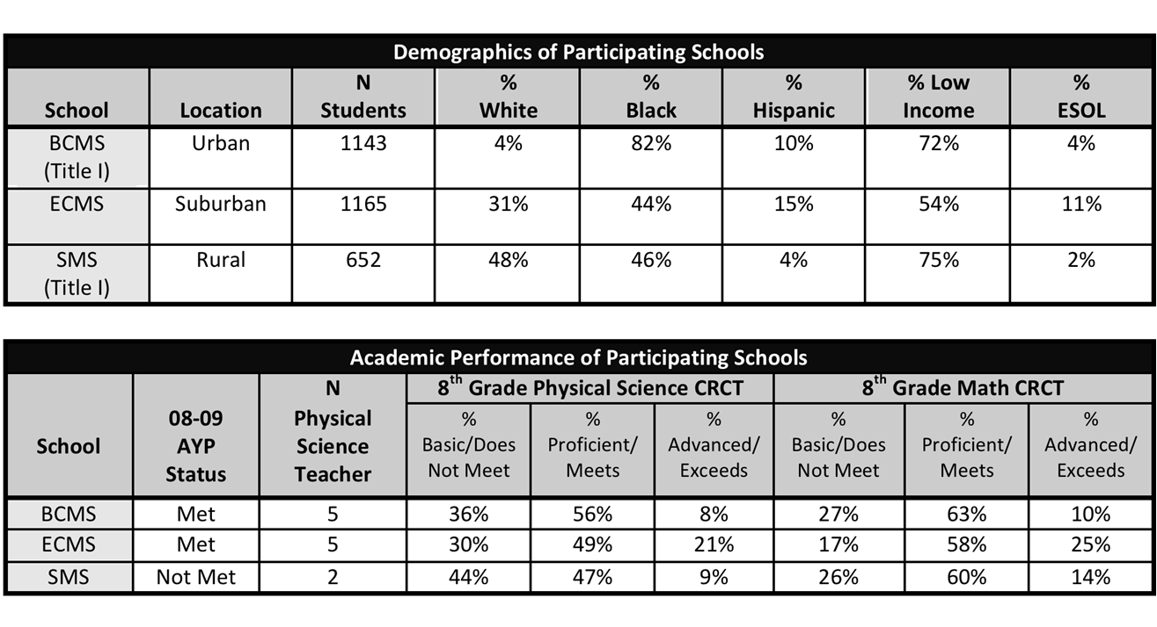
Eight teachers are participating in the project. Years teaching range from 6 to 24 (mean = 12; median = 10). Two teachers completed traditional teacher education programs, five completed post-baccalaureate programs leading to certification, and one completed a Masters of Arts in Teaching program. Six of the eight teachers have advanced degrees at either the masters or specialist level.

Current Work. This year we are developing and pilot-testing SLIDER materials. The curriculum team has created drop-in activities that utilize LEGO robotics sensors and data logging, and these will be implemented in classrooms during the second half of the year. For the temperature sensor activity, students run experiments to determine the type of cup that holds heat longest. In the ultrasonic sensor activity, students measure distances of objects to determine benefits and limitations of using the sensor for measuring. Regarding professional development, teachers completed initial training in problem-based inquiry science in July 2010 and are receiving additional professional development this academic year. In July 2011, they will participate in the second summer institute.

A number of research activities are also underway this year, including making site visits to participating schools, creating and pilot-testing instruments, and evaluating professional development. Table 3 provides specific research activities for this academic year.

Table 3. Research Activities for AY 2010-2011

July 2010 | August 2010 | September 2010 | October 2010 | November 2010 | December 2010
SLIDER Summer  Institute | Initial visit to East Cobb MS | Initial visits to Swainsboro MS and Bear Creek MS | School Observations
 | Review instruments for RQ2 | Create draft of instruments  for RQ2 | Pilot test instruments  for RQ 2
 |  | Request input from Advisory Board on  RQs 2 & 3 |  |  | Operationally define creativity and engagement with materials
January 2011 | February 2011 | March 2011 | April 2011 | May 2011 | June 2011
School Observations |  |  |  |  | Access school data (6th – 10th graders’ CRCT, EOCT, and GPA)
 | Second pilot test of instruments for RQ 2  (if needed) |  |  | Complete instruments for RQ 2
Evaluate SLIDER teacher training and curriculum
Create/locate instruments to measure creativity and engagement with materials |  | Pilot test instruments |  |  | Complete instruments

Future Work. Next year, we will pilot test modules in our participating schools with 8th grade students and collect data on the 7th graders who, as 8th graders, will participate in our first full-year SLIDER program. The five-year plan is provided in Table 4.

Table 4. SLIDER Project Activities and Goals Five-Year Plan

 | Project Activities and Goals
 | Curriculum | Assessment
Years  1 & 2 | -Teachers receive professional development in  problem-based inquiry science (PBIS) and  LEGO robotics  -Teachers integrate PBIS into their classroom  activities  -Teachers use LEGO data logging activities to  enhance classroom instruction  -SLIDER team develops LEGO robotics  curriculum and data logging drop-in activities  (Year 1)  -SLIDER team pilot tests and refines LEGO  robotics curriculum (Year 2) | -SLIDER team evaluates teacher  professional development  -SLIDER team operationally defines all  dependent variables and finds/develops  measurement instruments and data  collection strategies  -SLIDER team pilot tests instruments  -SLIDER team makes initial classroom/  school observations
Year 3 | -Teachers receive ongoing professional  development in LEGO robotics curriculum  -Teachers implement full-year LEGO robotics  curriculum in 8th grade physical science  classes (Cohort 1) | -SLIDER team collects data to assess  student learning (classroom data,  achievement test scores, etc.)  -SLIDER team collects student interest,  motivation, engagement data (pre & post)  -SLIDER team observes classrooms  -SLIDER team evaluates teacher  professional development
Years  4 & 5 | -Teachers receive ongoing professional  development in LEGO robotics curriculum  -Teachers implement full-year LEGO robotics  curriculum in 8th grade physical science  classes (Cohort 2) in Year 4  -Teachers implement full-year LEGO robotics  curriculum in 8th grade physical science  classes (Cohort 3) in Year 5 | -SLIDER team collects data to assess  student learning (classroom data,  achievement test scores, etc.)  -SLIDER team collects student interest, motivation, engagement data (pre and post)  -SLIDER team observes classrooms  -SLIDER team tracks students into high  school, analyzing achievement data and  gathering interest, motivation, and  engagement data

SLIDER Team and Contact Information

Principal Investigator:

Dr. Richard Millman, Director of the Center for Education Integrating Science, Mathematics, and Computing (CEISMC) and Professor Mathematics at Georgia Institute of Technology. richard.millman@ceismc.gatech.edu

Co-Principal Investigators:

Dr. Marion Usselman, Senior Research Scientist, CEISMC, Georgia Institute of Technology
marion.usselman@ceismc.gatech.edu

Dr. Donna Llewellyn, Director, Center for the Enhancement of Teaching and Learning and Adjunct Associate Professor in the School of Industrial & Systems Engineering, Georgia Institute of Technology
donna.llewellyn@cetl.gatech.edu

Dr. Juan-Carlos Aguilar, Georgia Department of Education Science Program Manager. jaguilar@doe.k12.ga.us

Curriculum Designers:

Mr. Michael Ryan, CEISMC Program Director, Georgia Institute of Technology. mike.ryan@ceismc.gatech.edu

Mr. Jeffrey Rosen, CEISMC Program Director, Georgia Institute of Technology. jeff.rosen@ceismc.gatech.edu

Mr. Bryan Gane, Doctoral Candidate, Department of Psychology, Georgia Institute of Technology.
bgane@gatech.edu

Research Personnel:

Dr. Cher Hendricks, Visiting Associate Professor, CEISMC, Georgia Institute of Technology. cher.hendricks@ceismc.gatech.edu

Dr. Barbara Burks Fasse, Senior Research Scientist, Coulter Department of Biomedical Engineering, Georgia Institute of Technology. bfasse@bme.gatech.edu

Dr. Richard Catrambone, Professor of Psychology, Georgia Institute of Technology. rc7@prism.gatech.edu

Administrative:

Ms. Anna Newsome, Program Coordinator, CEISMC, Georgia Institute of Technology. anna.newsome@ceismc.gatech.edu

Paper prepared for the National Science Foundation’s DR K-12 Principal Investigators’ Meeting, December 1-3, 2010, Washington, DC.

