2018 DR K-12 PI Meeting Call for Proposals:

Session Submission Form

CADRE invites proposals for awardee-led concurrent sessions that are responsive to the theme of the meeting and address topics of potential interest to subgroups of PIs. Sessions should go beyond a simple showcase of project work. Rather, presenters should address multiple perspectives on the theme. We also invite sessions that address project design, implementation, dissemination, and evaluation, such as issues related to methodology, measurement, partnerships, sustainability, or scale-up.

Since you will not be able to return to the site and edit your submission, we suggest that you collect the required information ahead of time—using this template as a guide—and transfer the information to the survey when ready. Please email cadre@edc.org with any questions or concerns.

Read the full Call for Proposals.
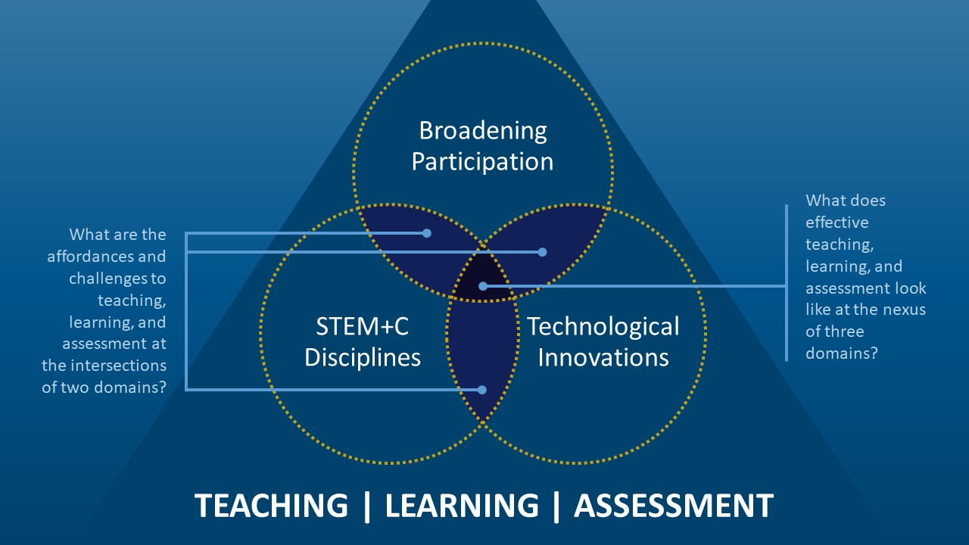

PROPOSED SESSION

Proposed Session Title (15 word limit)*

Session Format (pick one):*
☐Roundtable discussion
☐Structured poster session
☐Technical assistance session
☐Topical session
☐Working session

What question or issue is the primary focus of the session?*

Which thematic intersection(s) is addressed (choose all that apply)*
☐Broadening participation & STEM and computer science disciplines
☐STEM and computer science disciplines & Technological innovations
☐Technological innovations & Broadening participation
☐N/A, this is a proposal for a project design, implementation, dissemination, and evaluation session

Possible follow-up questions (in blue) based on response to previous question:

Broadening Participation Focus (choose all that apply)*
☐English Learners
☐Low Socioeconomic Status Students
☐Racial or Ethnic Minorities
☐Students with Disabilities or Cognitive Differences
☐Students in Rural Areas
☐Students in Urban Areas
☐Women and Girls
☐Other (list below)

Technological Innovation (choose all that apply)*
☐Adaptive Learning Technologies
☐Computational Modeling
☐Data Visualization
☐Learning Analytics/Education Data Mining
☐Gaming-based Learning
☐Makerspaces/Making
☐Mobile Learning
☐Online/Blended Learning
☐Robotics
☐Simulations
☐Social Networking
☐Technology-enhanced Assessments
☐Virtual/Augmented/Mixed Reality
☐Virtual/Remote Laboratories
☐Other (list below)

Content Area (choose all that apply)*
☐Science
☐Technology
☐Engineering
☐Math
☐Computer Science
Grade Band (choose all that apply)*
☐Pre-K
☐Elementary
☐Middle
☐High
☐Post-Secondary
☐Other (list below)

Audience (choose all that apply)*
☐Students
☐Teachers
☐Preservice Teachers
☐Informal Educators
☐Administrators
☐Post-secondary Faculty
☐Families
☐Other

Context*
- Formal
- Informal

Emphasis*
☐Teaching
☐Learning
☐Assessment

Session Summary for Agenda: (25 word limit)*

Full Session Description ((approximately 250 words, no graphics; include the objectives, structure/format, and plan for interaction with the participants of the session)*

PRESENTER(S) INFORMATION
(Proposed presenters must be invited and registered for the meeting)

Presenter Name*

Presenter Organization*

Presenter Email*

Presenter Phone Number (Format XXX-XXX-XXXX)*

Is presenter #1 representing a DRK-12 project, a STEM + C project, or both?*
☐DRK-12
☐STEM+C
☐Both
Your response will generate a list of projects to choose from.

Is there more than one presenter?*
☐Yes
☐No
Selecting yes re-populates PRESENTER(S) INFORMATION fields for additional presenters.

MAIN CONTACT PERSON AND SESSION LIMITATIONS

Who is the main contact person for this session (Name)*

Main contact person’s email*

Main contact person’s phone number*

If you have any limitations such as the date and time that you can present or the number of people that may participate in your session, please describe those limits below

